**CABer**

**CSE2004 Database Management System**

**Project Report**

**Submitted by**

*Pranav Raj 19BPS1041*

*Kunal Kumar Jha 19BCE1212*



**School of Computer Science and Engineering**

**April 2020**

**Table of Content**

Page Number

Project Details - 3

E-R Diagram - 4

E-R to Relational model - 5

Normalized Table - 6

**CABer**

Introduction

CABer is derived from an idea that during the vacation all the hosteller find it very difficult to find the partner for cab and at time when the book their flight to their respective cities. This database project will help will them to find the companion for their long homecoming journey and will help to share the huge cash demanded by the cab driver.

Objective:

The objective is to show every names and contact numbers of those student whose time, date and destination (e.g. Chennai railway station, domestic airport, etc.) clashes with the other students. This will help them to share their cab fares and take the flight (if applicable) with their friends going to same place.

Advantages:

1. This will minimize the consumption of huge amount of fuel and also minimizes the pollution.

2. This will also save the money of students and give a good company for the journey.

**ER diagram**

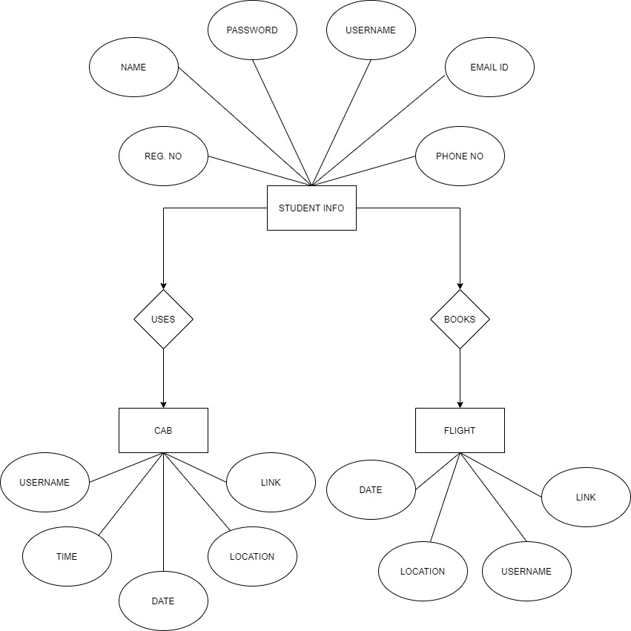

**ER diagram to relational model**

After transforming the above given ER diagram to relational model, we get three tables

1. **Student** (Username, Name, Regno (Registration Number), Password, Phone No, EmailId)

2.**CAB** (Username, Time, Date, Location, Links)

3.**Flight** (Username, Date, Destination, Links)

**Normalized tables**

Student table is completely normalized.

But CAB and Flight does not follow the fourth normal form, since the is multi-valued dependencies between location, link and destination, link respectively hence we need to split those tables into two.

Normalized tables

1. **Student** (Username, Name, Regno (Registration Number), Password, Phone No, EmailId)

2.**CAB** (Username, Time, Date, Location, Links)

3.**Flight** (Username, Date, Destination, Links)

4.**CABLinks** (Location, Links)

5.**FlightLinks** (Location, Links)